Notice from the City Assessors, as found in the Nowthen Spring Newsletter -
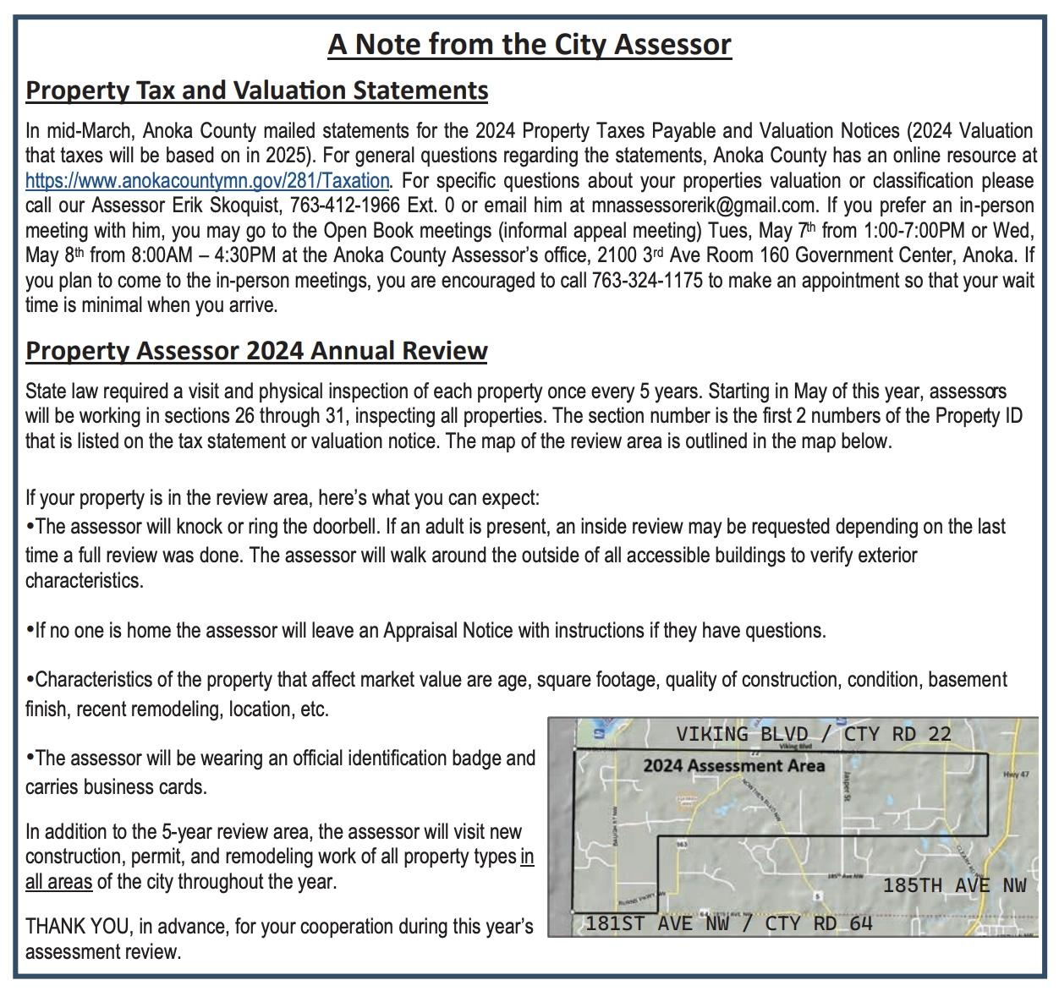

Check out the Anoka County Assessors page for more information-
https://www.anokacountymn.gov/4276/Assessment

